|  |
| --- |
| Free Recall |
| Sebastian Beck  PJG511 |
| 4/12-2019 |

Index

Introduction 3

Method 3

Materials 3

Test procedure 3

Results 4

List type and word position matters 4

We found primacy and recency effects 5

Primacy effect doesn’t mitigate list type differences 6

Conclusion 6

References 7

# Introduction

There are many models concerning memory; how we encode, consolidate and retrieve information from our memory (Purves et al., 2013; Radvansky & Ashcraft, 2014). One of such models are Paivios dual coding hypothesis, which states that words describing concrete objects, can be encoded twice into memory. Once in terms of their verbal attributes and again in their imaginal attributes. Contrary to this, abstract words are only encoded once through their verbal attributes (Fiebach & Friederici, 2003; Radvansky & Ashcraft, 2014, p. 191). The context availability model is another of such models, this also states that concrete words are easier encoded into memory than abstract words. The reason for this is being, that concrete words are more heavily associated with other concepts, or that semantic representations of abstract concepts contain less information that concrete concepts (Fiebach & Friederici, 2003). This experiment aims to test this shared hypothesis that concrete words are easier recalled than abstract words.

Furthermore, the experiment aims to test two serial position effects: primacy- and recency effects. Primacy effect refers to the accuracy of recall for the earliest words of the list, while the recency effect refers to accuracy of recall for the last words of the list. Both effects predict a higher probability of recall, the primacy due to more rehearsal and the recency due to the words still being available in the short-term memory (STM). Recency effect being linked to STM, means it can be erased by occupying STM between encoding and recalling the list of words (Radvansky & Ashcraft, 2014, p. 145).

# Method

This experiment included *N* = 86 participants, all psychology students at UCPH. Sex and age differences were not considered.

## Materials

* Wordlists: Five concrete and four abstract, 20 words in each list.
* Stopwatch

## Test procedure

Three persons were present during the experiment: the experimenter (E), an observer (OB), and the participant (P). P was sat perpendicular across to E and OB, in order to minimize distractions while still being able to hear the words clearly. During the experiment E read aloud at a two seconds interval the 20 words on the list. Immediately after the reading had concluded, P were asked to recall as many words from the list as possible, in any order the words were remembered. OB recorded correct and misremembered words. E alternated between reading concrete and abstract lists. Each P had one interference list chosen at random from the concrete wordlists. The P was not informed nor warned about the interference list beforehand. The interference differentiated from the regular lists by including an interference task. Before immediately recalling as many words as possible, P was asked to count backwards from 392 by continually subtracting 3. After 30 seconds of backwards counting, P was asked to recall as usual.

# Results

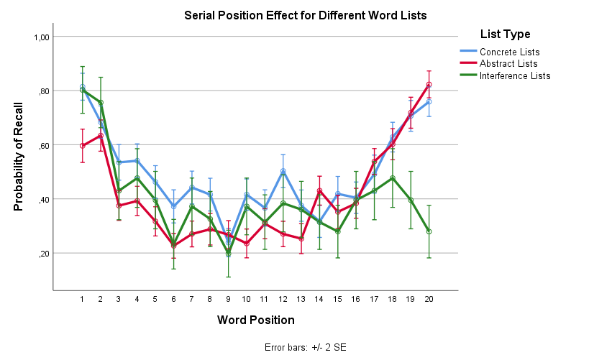

Figure 1: Shows the Serial Position Effect for each word in each of the three different lists. The graph shows both recency and primacy effects for concrete and abstract lists, but only primacy effect for the interference list.

## List type and word position matters

Figure 1 shows differences in recall probability dependent on word position and list type. This was confirmed through a repeated measures ANOVA which showed significant main effects of list type, *F*(1.69, 143.86) = 25.23, *p* < .001, $η_{p}^{2}$ = .23 (Huyhn-Feldt corrected), and of word position, *F*(16.05, 1364.42) = 50.23, *p* < .001, $η_{p}^{2}$ = .37 (Huyhn-Feldt corrected). There was a significant interaction between list type and word position, *F*(28.24, 2400.28) = 7.82, *p* < .001, $η_{p}^{2}$ = .08 (Huyhn-Feldt corrected). Even when interference was not included, list type still showed a significant main effect, *F*(1, 85) = 52.67, *p* < .001, $η_{p}^{2}$ = .38. The main effects show that recall probability does depend on what type of list is used, and where on the list a word is placed. The interaction shows that this varies dependent on list type. As shown in figure 1, concrete words have a higher probability of recall than abstract words, which supports the hypothesis.

## We found primacy and recency effects

Figure 2: Shows Serial Position Effect for FP19301. This illustrates primacy and recency effects, supporting the hypothesis.

In order to test for the primacy effect, a paired samples *t*-tests was conducted. This showed significant differences in mean recall probability between the first two words (*M* = 0.75, *SD* = 0.22) and the middle four words (*M* = 0.38, *SD* = 0.20) in the concrete words list, *t*(85) = 15.53, *p* < .001, *d* = 1.75, and in mean recall probability between the first two words (*M* = 0.61, *SD* = 0.23) and the middle four words (*M* = 0.27, *SD* = 0.17) in the abstract words list, *t*(85) = 14.57, *p* < .001, *d* = 1.74 as well as in mean recall probability between the first two words (*M* = 0.78, *SD* = 0.33) and the middle four words (*M* = 0.32, *SD* = 0.30) in the interference words list, *t*(85) = 9.94, *p* < .001, *d* = 1.47.

As summarized in table 1, this clearly shows that the probability of recall for the first two words are higher than for the middle four words, which indicates a primacy effect.

In order to test for recency effect, a paired samples *t*-tests was conducted. This showed significant differences in mean recall probability between the middle four words (*M* = 0.38, *SD* = 0.20) and the last two words (*M* = 0.73, *SD* = 0.22) in the concrete words list, *t*(85) = -11.12, *p* < .001, *d* = -1.65, and in mean recall probability between the middle four words (*M* = 0.27, *SD* = 0.17) and the last two words (*M* = 0.77, *SD* = 0.23) in the abstract words list, *t*(85) = -18.35, *p* < .001, *d* = -2.55. No significant difference was found in mean recall probability between the middle four words (*M* = 0.32, *SD* = 0.30) and the last two words (*M* = 0.34, *SD* = 0.40) in the interference words list, *t*(85) = -0.41, *p* = .68, *d* = -0.06.

As illustrated in figure 2 and summarized in table 1, we found a significant recency effect in the concrete and abstract lists but not in the interference list. This shows a recency effect and supports the hypothesis.

|  |  |  |  |  |  |  |  |  |
| --- | --- | --- | --- | --- | --- | --- | --- | --- |
| Table 1 *Average probability of recall for each word list type for select word positions.* | | | | | | | | |
|  | First Two Words | |  | Middle Four Words | |  | Last Two Words | |
| Word list | *M* | *SD* |  | *M* | *SD* |  | *M* | *SD* |
| Concrete Lists | 0.75 | (0.22) |  | 0.38 | (0.20) |  | 0.73 | (0.22) |
| Abstract Lists | 0.61 | (0.23) |  | 0.27 | (0.17) |  | 0.77 | (0.23) |
| Interference Lists | 0.78 | (0.33) |  | 0.32 | (0.30) |  | 0.34 | (0.40) |
| *Note: Recall is shown as mean probability* | | | | |  |  |  |  |

## Primacy effect doesn’t mitigate list type differences

In order to test for the primacy effect, a repeated measures ANOVA was conducted to test whether the probability of recalling the first two words in a list varied between list conditions.

A repeated measures ANOVA showed a significant main effect of list type, *F*(1.65, 140.49) = 13.05, *p* < .001, $η_{p}^{2}$ = .13. As shown in table 1, concrete words have a higher probability of recall than abstract words, even when only the first two words are considered.

# Conclusion

Results of the experiment provides evidence for the hypothesis of higher recall probability for concrete words than for abstract words. Likewise, it provides evidence for the primacy and recency effect, and that the recency effect can be erased by occupying STM.

# References

Fiebach, C. J., & Friederici, A. D. (2003). Processing concrete words: fMRI evidence against a specific right-hemisphere involvement. *Neuropsychologia*, *42*, 62–70.

Purves, D., Cabeza, R., Huettel, S. A., LaBar, K. S., Platt, M. L., & Woldorff, M. G. (2013). *Principles of Cognitive Neuroscience* (2nd ed.). Sunderland, Massachusetts: Sinauer Associates, Inc., Publishers.

Radvansky, G. A., & Ashcraft, M. H. (2014). *Cognition* (6th ed.). Upper Saddle River: Pearson Education.